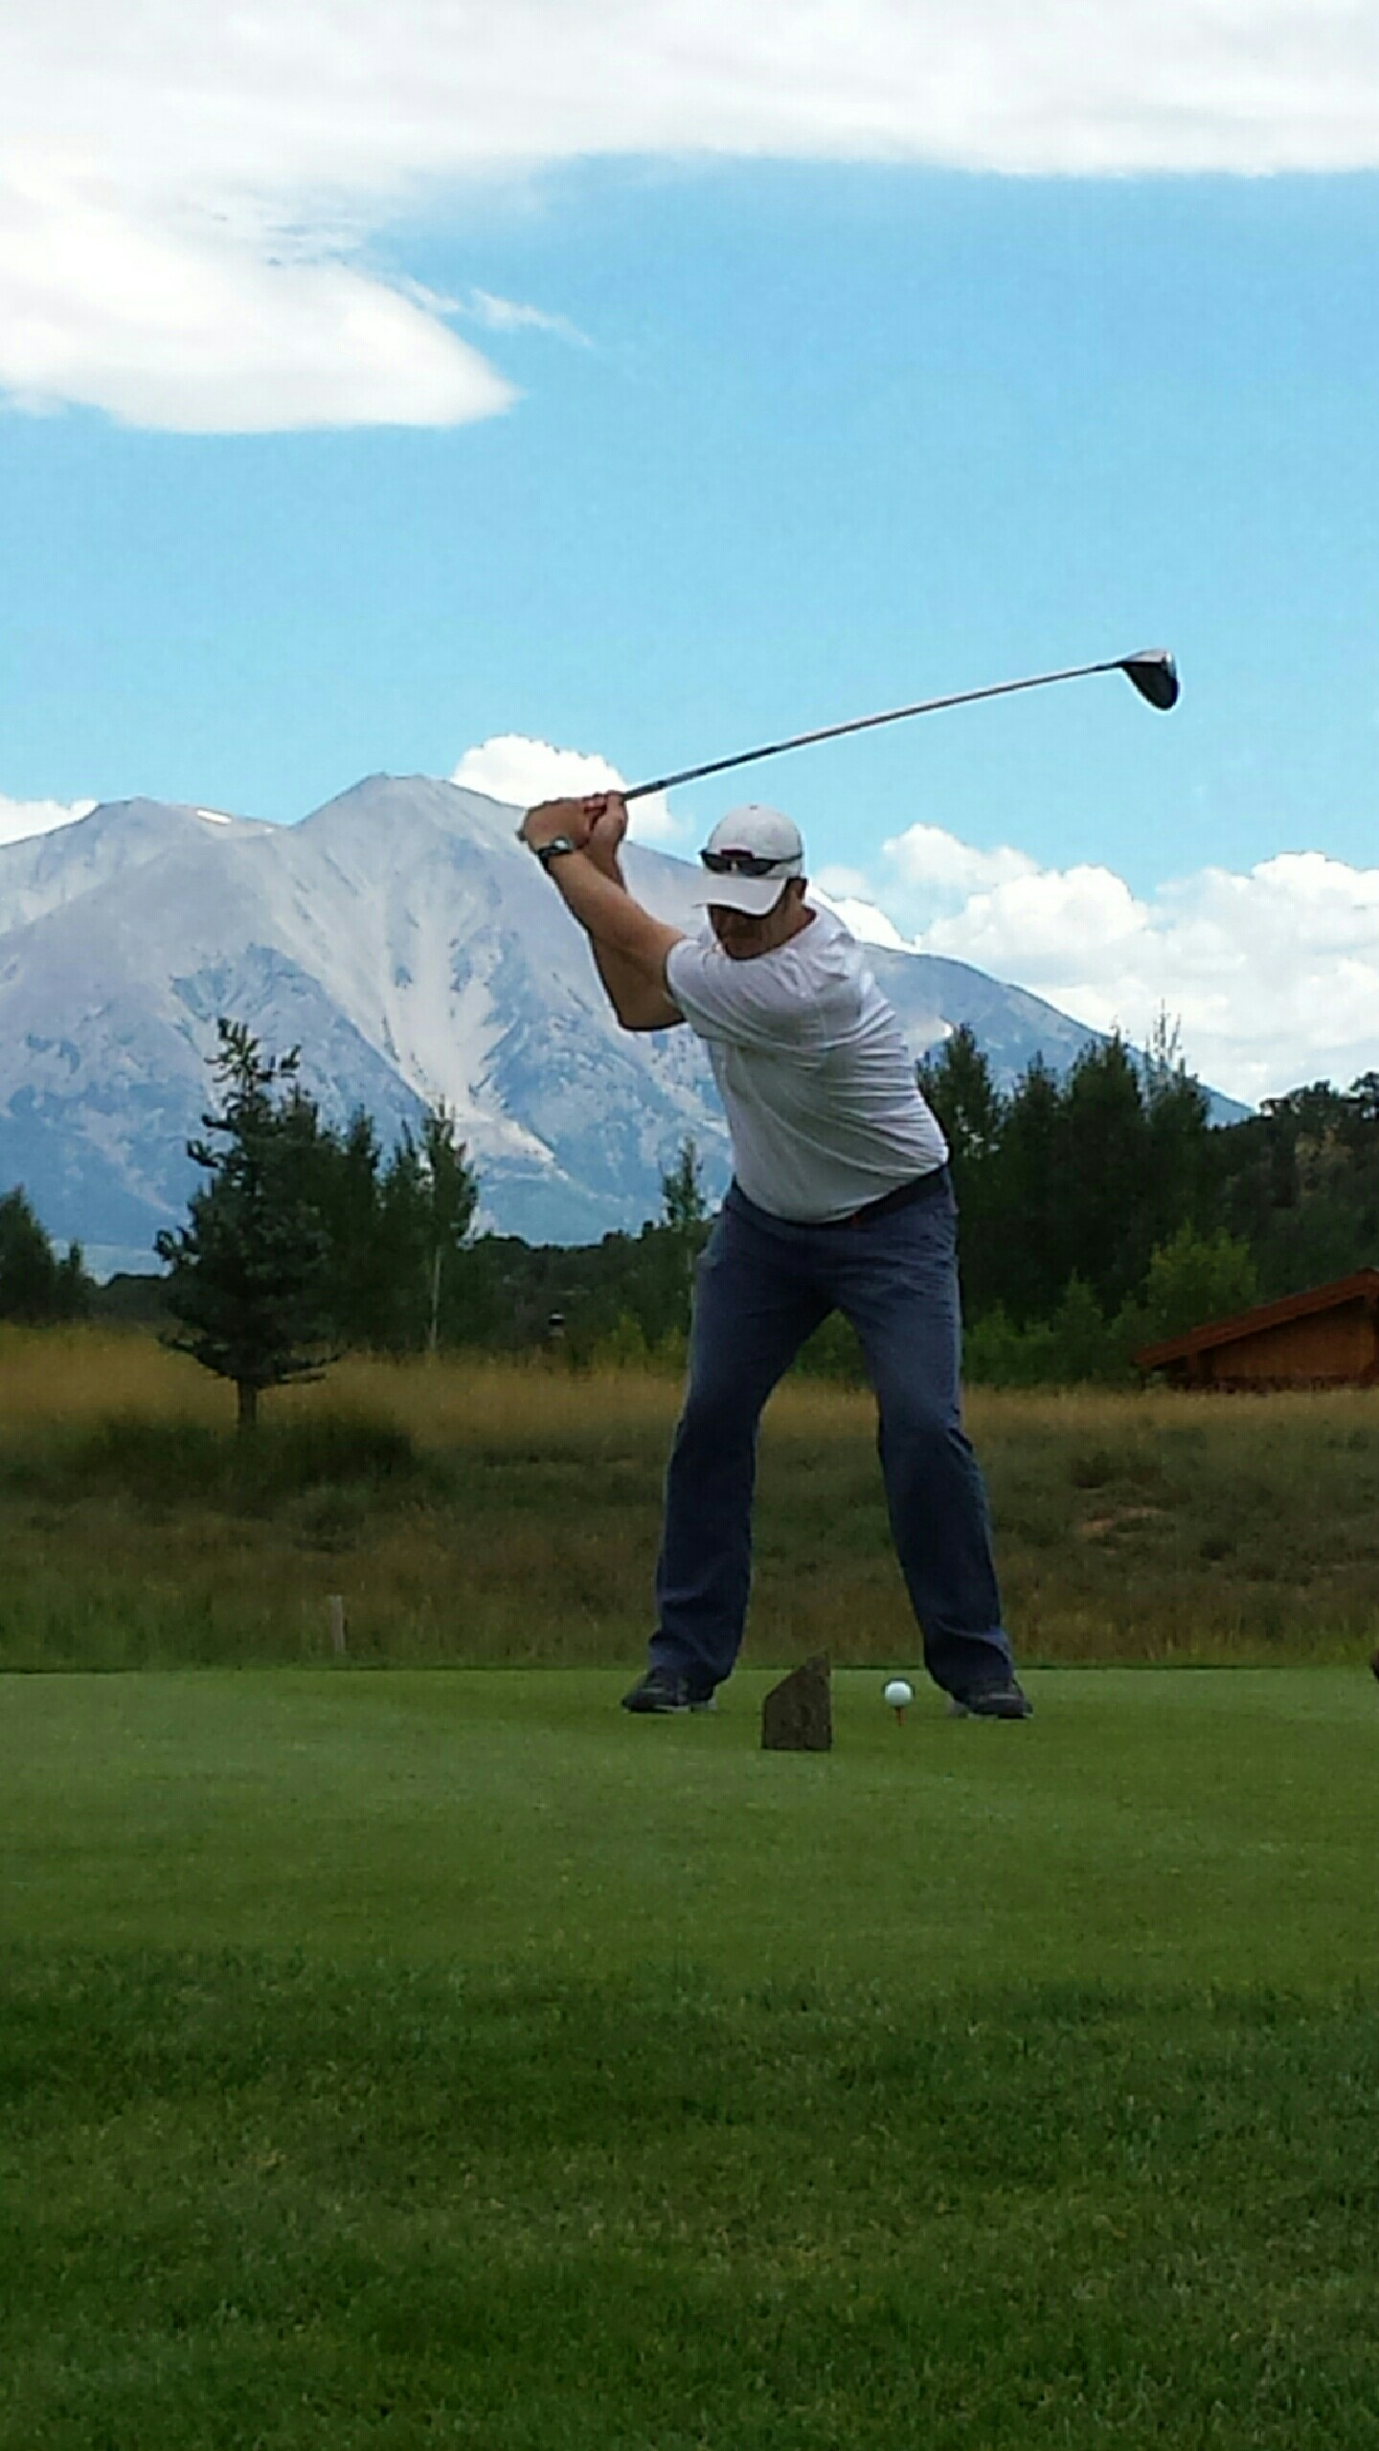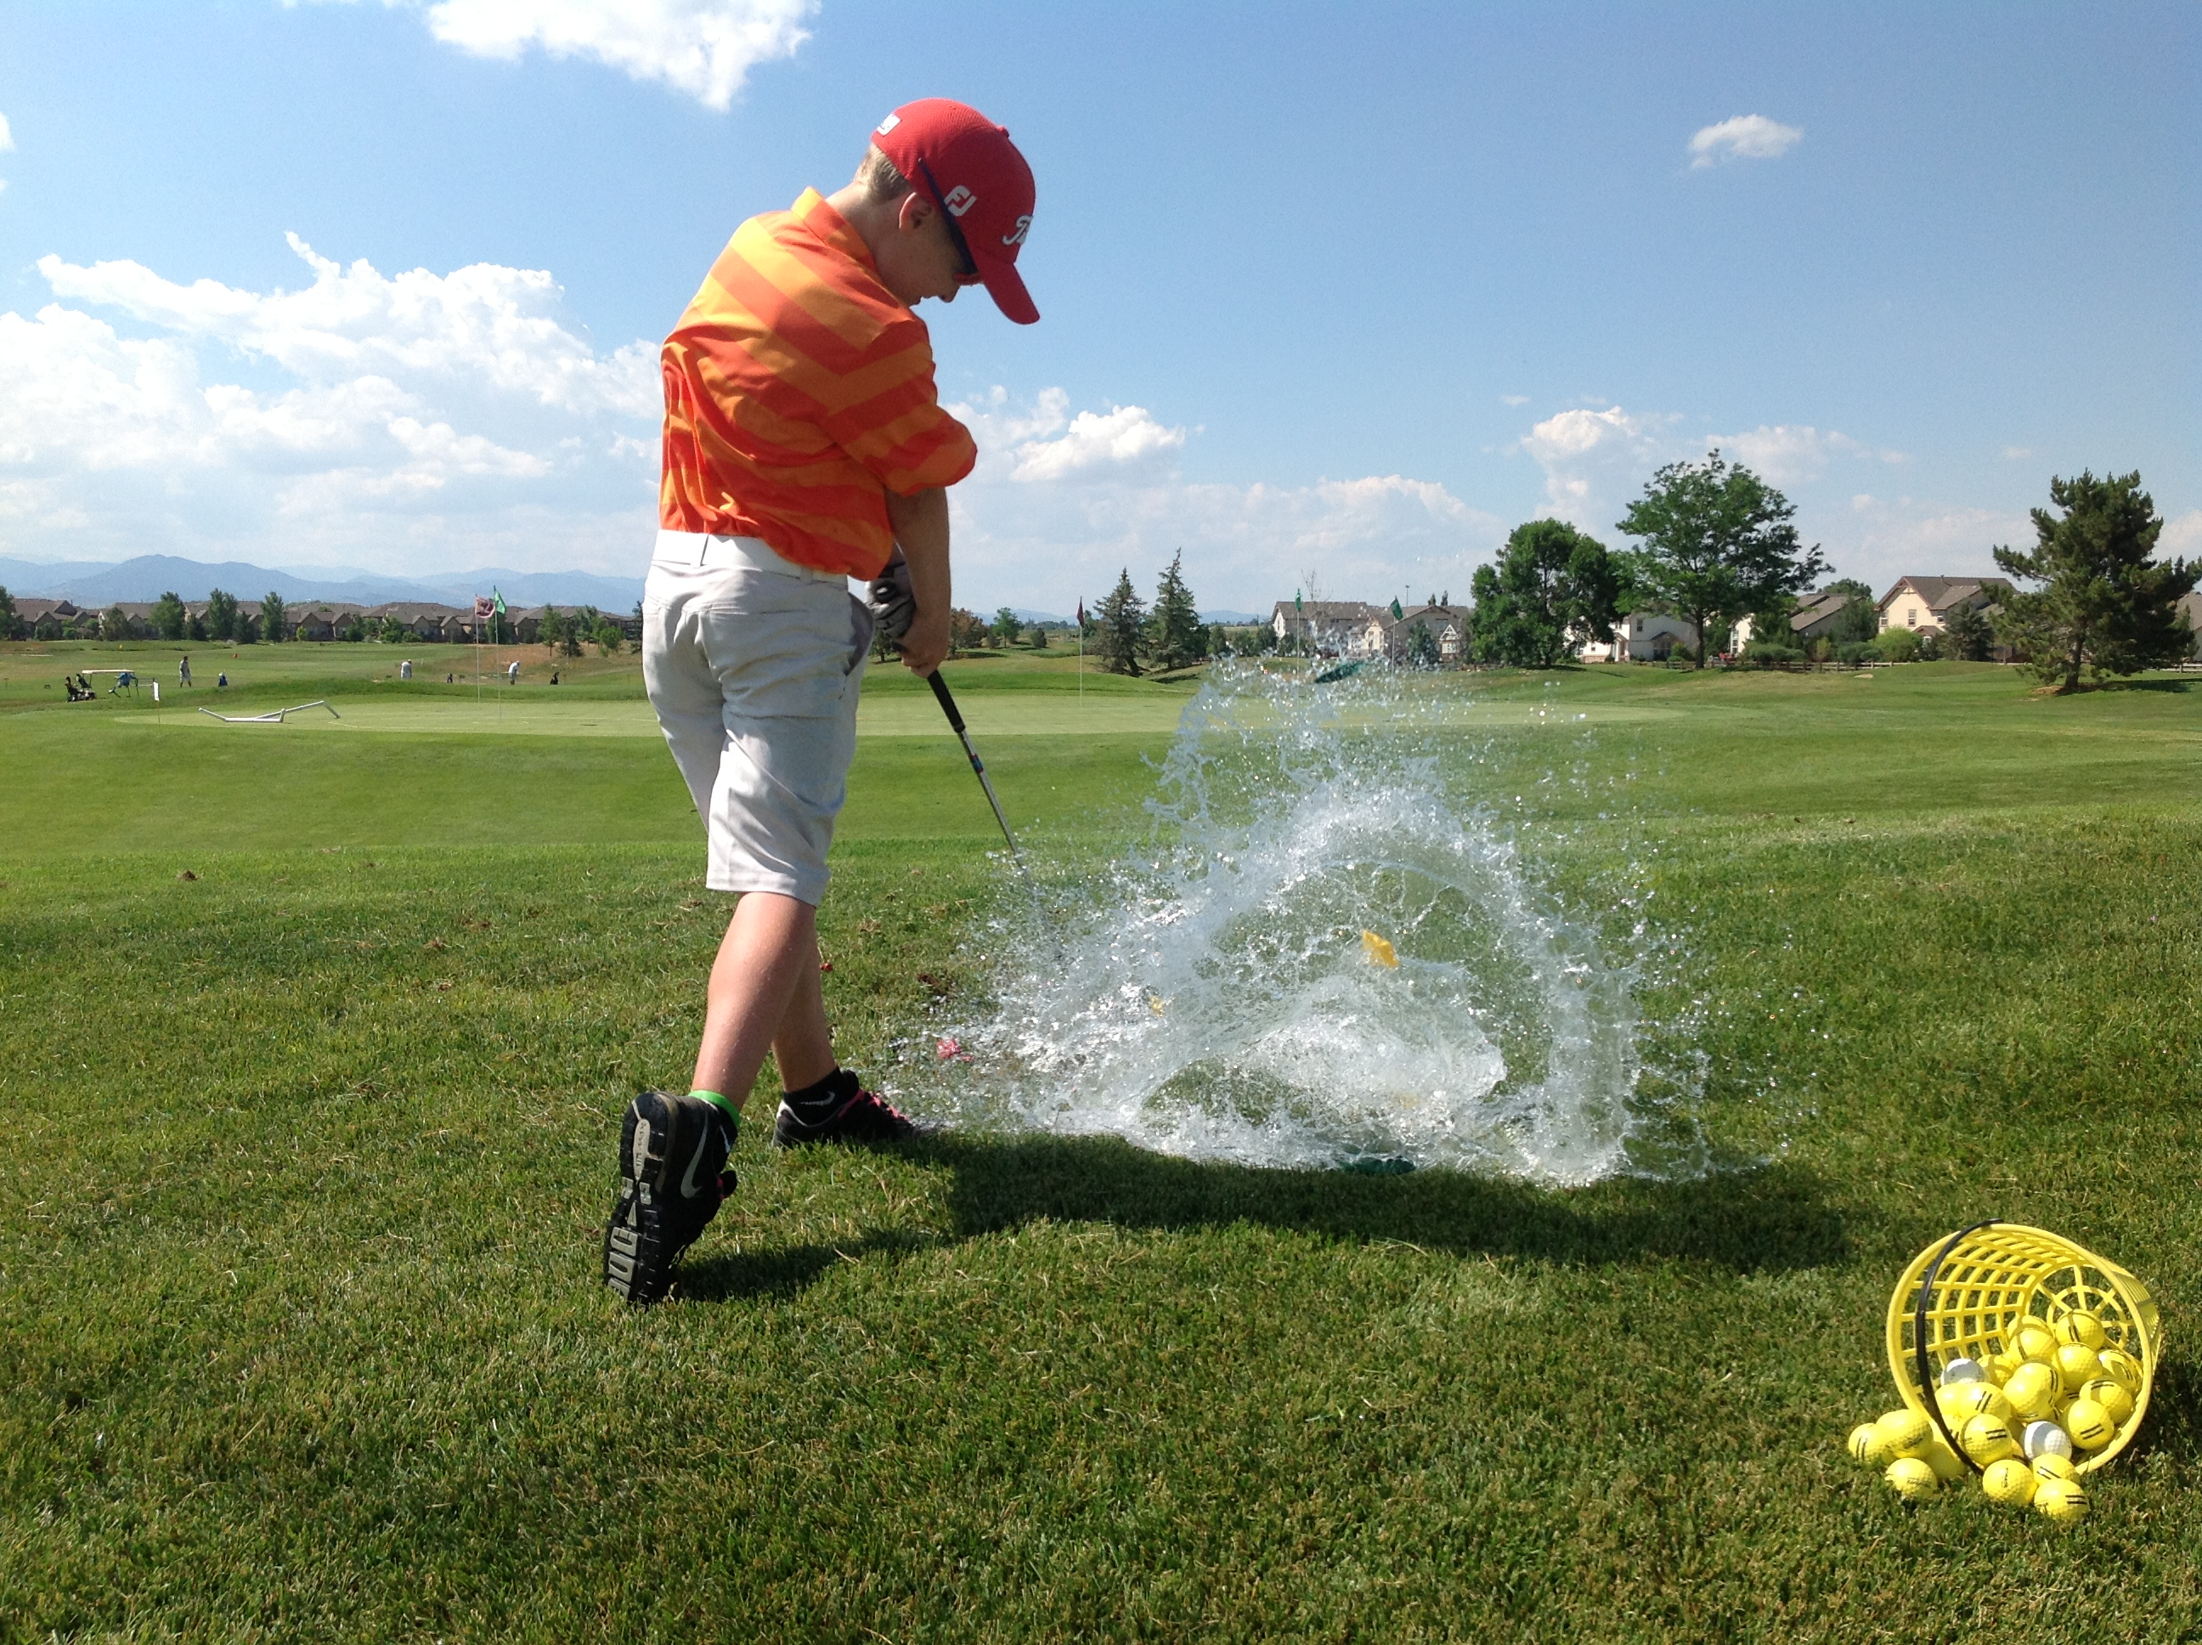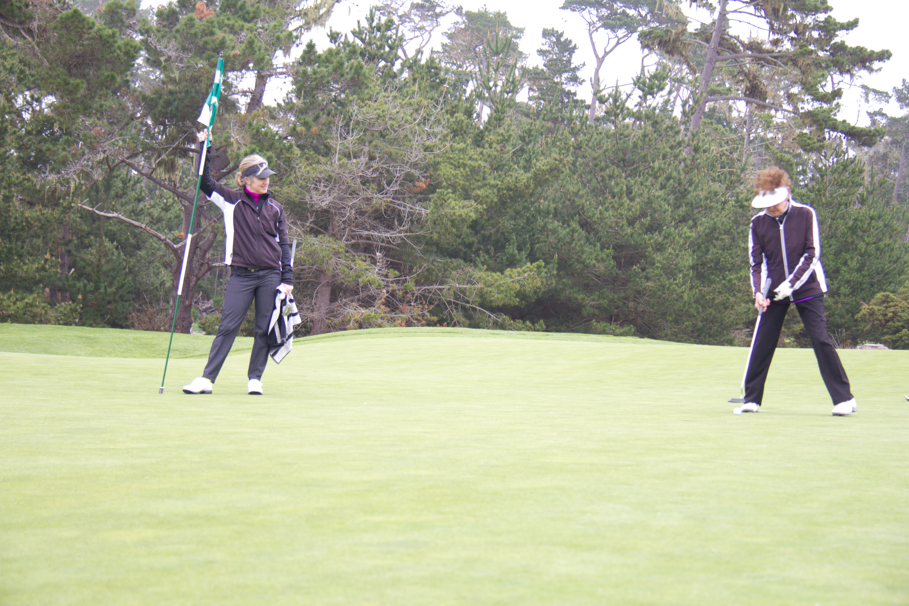

Tray Shehee, PGA

(303) 875-5050

traygolf@q.com

🙞 🙜

### One Hour Adult $ 100

### Series of Five $ 450

### Series of 12 $ 960

### Junior under 18 $ 80

### Series of Ten $ 750

🙞 🙜

Private Golf

Instruction with

Tray Shehee

PGA Professional

(303) 875-5050

Groups are 3 weeks $165 per student

4-8 adults per group

No experience necessary

Learn how to play golf

with Tray Shehee

PGA Professional

Improve your skills in

putting, chipping, sand,

full swing, irons, woods and much more!

Call, text, or email Tray

to register for groups

#### Group #1 April 10,17,24

#### Group #2 May 8,15,22

#### Group #3 June 12,19,26

#### 5:30-7:00pm

# Ute Creek

# Adult Golf Classes

Open to junior golfers

Ages 8-17

No experience needed

No registration drop-in only

Thursdays June 7 – July 12

11:00am-12:30pm

Each Thursday for 6 weeks

$25 per class, cash or check

Just show up

and have fun!

## Junior Golf

## Ute Creek Golf Course